Phone Number Verification through SMS/Voice.

Introduction

Verifying that a user owns a phone number has a few similar uses. A common mobile application use case is a one time verification on registration or installation.

First the mobile application collects the number for the user from the landing screen. On click of submit the code is sent to the number via SMS, and the application prompts the user to provide that code after every XXX secs with the status of the message send.The provided code has validity till 90secs.

After 90 secs of unsuccessful verification a fallback screen appears which display the DID number for VOICE verification. This attempt is also valid till 90 secs.
The user need to give a missed call within this time duration on the provided DID number.

On each attempt of code verification, the user gets the success/failure message.

How-To
Step 1. : Enter your customer ID, otpUpdateTimer and App Key in constants.js file as required and html being verificationRequest.html
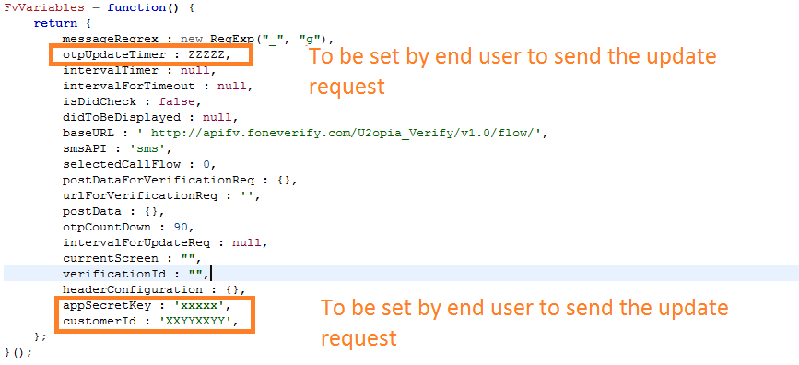

Step 2 : Enter your mobile number in the landing screen.
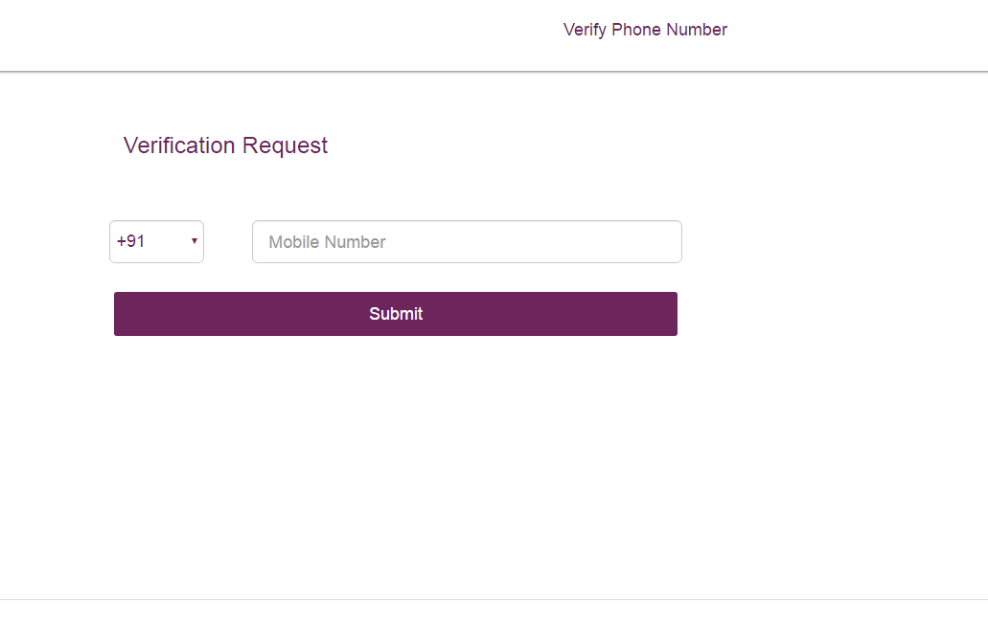

Step 3 : Enter the OTP send on the provided mobile number within below shown time. ie sms_update_request.html.

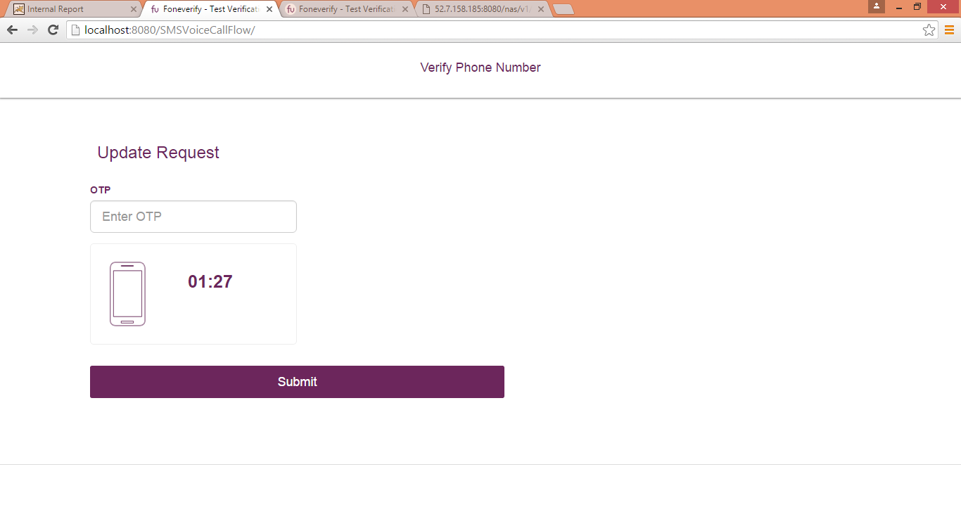

Step 4 : On successful verification

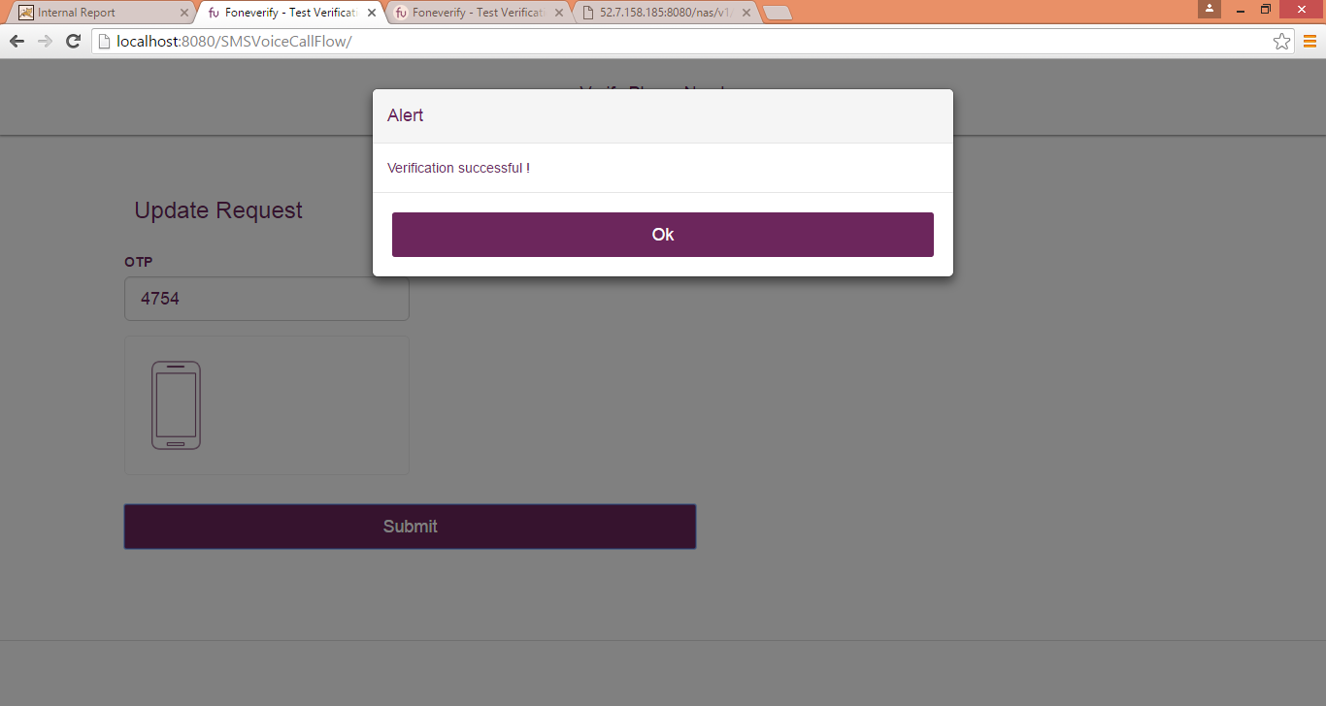

Step 5 : On unsuccessful attempt fallback screen will appear on time out ie 90secs.ie fallback_sms.html

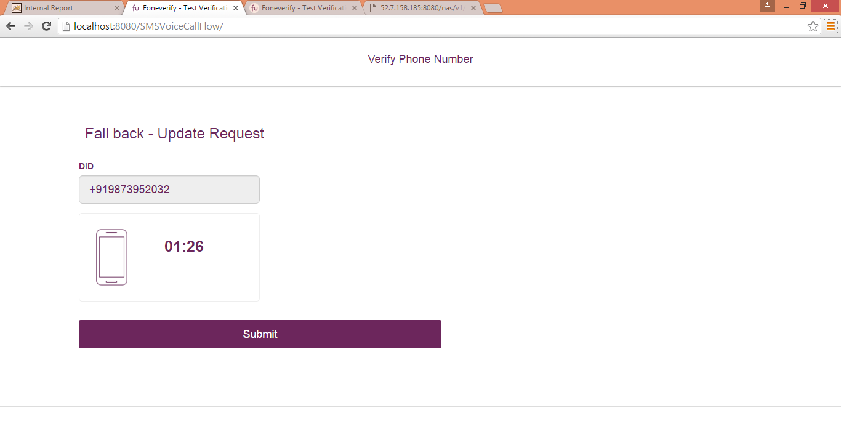
Step 6 : On successful verification success message will appear..

Step 7 : On unsuccessful attempt failure message will be provided.

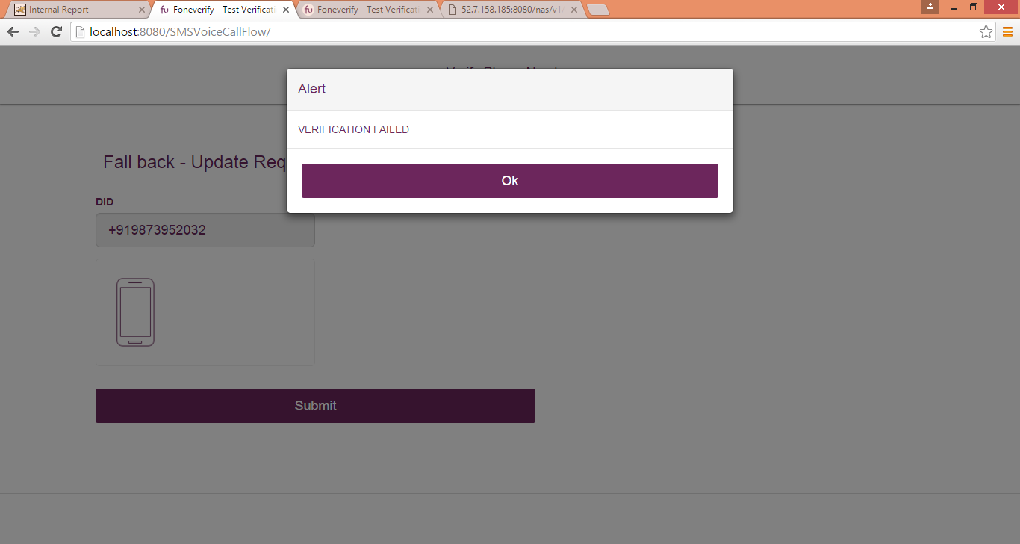

Code Walk through

Step1. On click of submit after entering mobile number, foneverify.submitVerficationReqCall() is called in index.js.
Using rest API URL :
var url = FvVariables.baseURL + FvVariables.smsAPI;
Where FvVariables is constant object containing URL.

Step2. On success message with 200 code loads sms_update_request.html
if (endpoint == 'sms') {
FvVariables.currentScreen = 'smsUpdateRequestScreen';
foneverify.resetVerificationScreenDivCss('smsUpdateScreenDiv');
$("#smsUpdateScreenDiv").load("html_templates/sms_update_request.html");

Step3. For update after every XXXsecs.
foneverify.updateVerificationRequest() is called.
On the basis of response code further steps like navigate to fallback screen or show success or failure message is performed.

